**Assignment #1**

**Introduction to Linux**

Problem Statement:

Hi Robin, this is Batman speaking. I have some photographic evidence of Joker activities regarding recent riots broke out in Arkham City. I want you to create a directory in my UbuntuOS with name “Joker_Arkham_Riot_Evidence_2024” so that I can save the photographs there.

Solution:

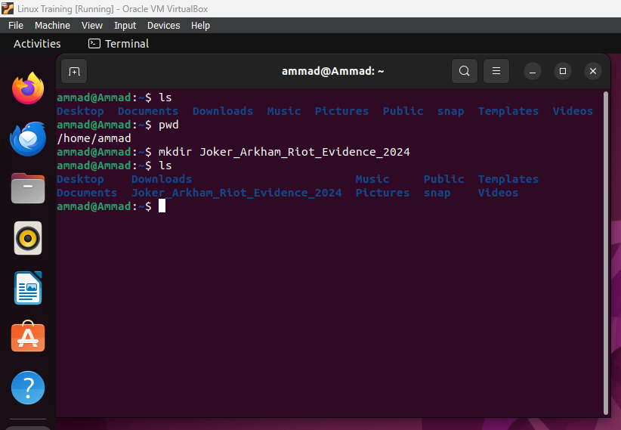

First, I ran the ls command to check which directories are already present in the current directory. I also ran the pwd command to check if I am in the right directory (for which I have the write access). As I was in “/home/ammad”, I ran the mkdir command with the name of the new directory that I had to create. Upon running ls again, you can see that the directory has been created.